Scott Chamberlain
CSD325 Module 9.2 Assignment
5/11/2026

Test – 200 = successful!
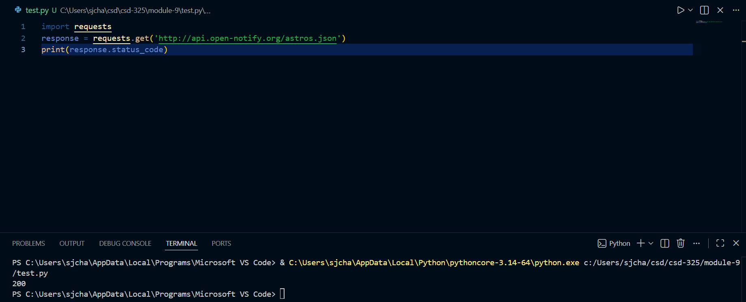

Astronauts
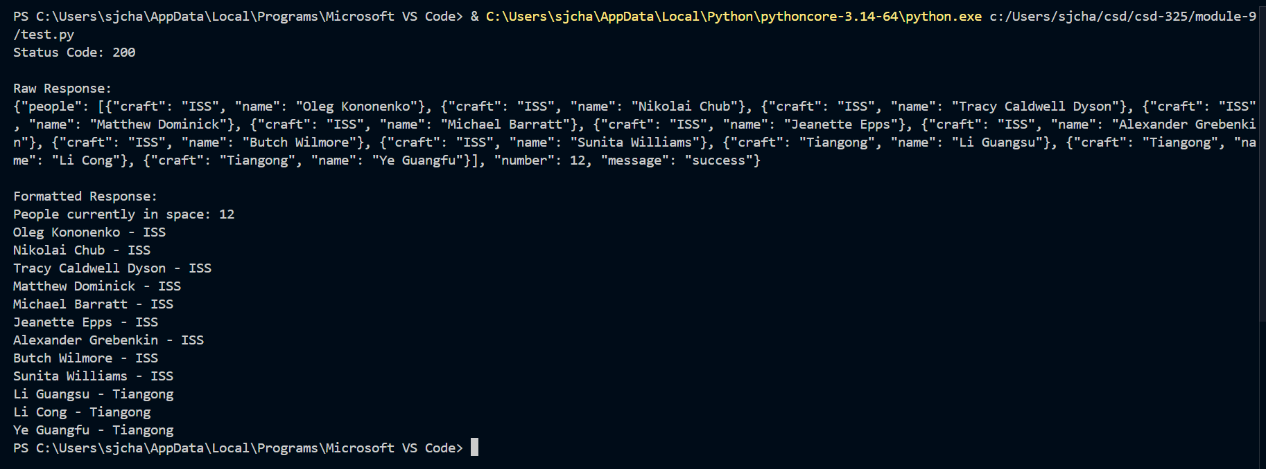

Random facts connection test – 200 means successful!
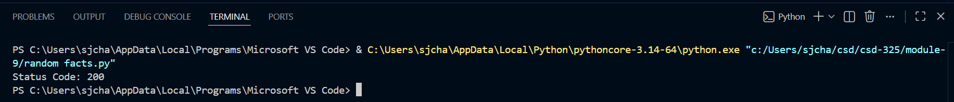

Random facts API
